Cobots ( collaborative robots )

A Project Report Submitted
for

Information Technology
By
Sakshi Gururani

Under the guidance of
Mr. Praveen Kumar Joshi



EVER GREEN SENIOR SECONDARY SCHOOL
(GOVERNED BY EDUCATIONAL WELFARE SOCIETY)
TULARAMPUR - 223139, DISTRICT-NAINITAL
UTTARAKHAND, INDIA

OCTOBER, 2021

CERTIFICATE

This is to certify that the project entitled “cobots ” being submitted to Evergeen Senior Secondary School, Haldwani for the project work of INFORMATION TECHNOLOGY is a record of the work carried by SAKSHI GURURANI under my guidance and supervision.

Date: Supervisor
MR. PRAVEENJOSHI
TGT Computer
Ever Green Sr. Sec. School, Haldwani
Forwarded By:
MR. M.S. PARWAL
Principal
Ever Green Sr. Sec. School, Haldwani

ABSTRACT
A cobot , or collaborative robots is a robot, intended for direct human-robot interaction within a shared space or where humans and robots are in close proximity. Robot application construct with the traditional industrial robot applications in which robots are associated from human contact.

ACKNOWLEDGEMENTS
I would like to express my most sincere heartfelt gratitude and respect to my supervisor MR. PRAVEEN JOSHI, for suggesting the topic for my project work and for his excellent guidance, valuable suggestions and endless support throughout for preparing the report. I am greatly indebted to him for his constructive suggestions and criticism from time to time during the course of progress of my work.
I would like to express my gratitude and sincere thanks to Mr. M.S. Parwal, Principal of School, and entire faculty who has imparted considerable knowledge to me.
Finally, I express my deepest gratitude to my parents for their continuous encouragement, understanding and support.

(Sakshi Gururani )

TABLE OF CONTENTS

Chapter. | Topics  Certificate  Acknowledgement  Abstact  Introduction | Page No.
1. | Collaborative
2. | The IFR defines
3. | ( History )
4. | Four types of cobots operation
5. | Advantages
6. | Disadvantages
7. | Summary and future work
 | REFERENCES ---

Introduction
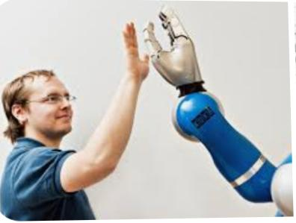
What is collaborative ?
Produced or involving two or more parties working together to complete a task or achieve a goal. collaboration is similar to corporation must collaboration requires leadership, all through the form of leadership can be social within decentralized and egalitarian group.


What is collaborative robots ..?
Are robots specially design for direct interaction within a defined collaborative workplace.. A collaborative robot are are experiencing rapid market growth in this sector of a robotic industry the primary driving force behind this growth is consistently decreasing price.
Cobots application constrast with traditional industrial robot application in which robots are isolated from contact. robot safety on lightweight construction material rounded edges and inherent limitation of speed and force or on sensors and software that ensure safe behaviour.
The IFR defines :
It define s four level of collaboration between industrial robot and human workers:
Coexistence : human and robot work alongside each other without a fence , but with no shared workspace.
Sequential collaboration : human and robot are active in shared workspace but their emotions are sequential; they do not work on a part at the same time.
Corporation: robot and human work on the same part of the same time with both in motion.
Responsive collaboration : the robot response in real-time to movement of the human worker.

History :

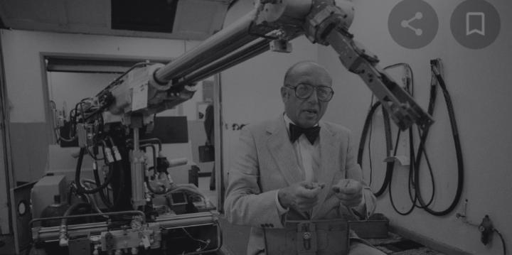

The cobots word invented in 1996 by j advance Colgate and michael peshkin professor at northwestern University. Colgate and peshkins 1997 us patent entitled cobots describe an apparatus and method for direct physical interaction between a person and a general purpose manipulator controller by a computer .

In first cobots assured human safety by having no internal source of motive power Instinct motive power was provided by human worker.

KuKa release its first cobot , LBR 3 in 2004. this computer control rate robot was the result of long collaboration with the German aerospace centre institute .
U.R released its first cobot the UR 5 in 2008.

4 types of cobots operation:
Power and foods limiting :
cobots: Power ranger force limiting cobots likely what most people think of collaborative robot. They are designed specially to sense contact with people and erase eliminating the need for safety barriers. they are best for smaller application.
Safety rated + monitoring stop cobots : detect when a person has entered a design it'd area in stop operating unit the person leaves that shared work place eliminating the need to have to restart a robot with the push of a button .once the person leaves, robot automatically continues its task. not as much interaction between person and robot.
Speed and separation cobot (also called fenceless ) : more simple referred to as fenceless cobots - work well when there is not much interaction with the person but a person access to the robot.
Hand guiding cobots : finally hand guiding ko boards have a safety rated device attached to end of the robots arm to allow a person to manully guide aur move the robot around. Quickly and easily program new robot paths and position by hand.

1- Cobots are flexible, easy to install and relocate .
2-Cobots are safer than industrial robot.
3-Cobots are cost effective.
4-Positive effect on employees.
5-Cobots can be armed and program task is even faster.

- Because the robot are collaborative , they cannot work without human assistance and supervision.
- They let humans to lost their jobs.
- Cobots might not be efficient as six- axis robots .
- Cobots speed is limited.
- They have no emotions .

SUMMARY
Cobots have been around since 1990 s. cobots operate in in conjunction with humans to perform given task .they are built to interact physically with humans in a shared work space …. Robots help in improving human capability in performing task with greater strength accuracy ,and data capabilities
. FUTURE WORK
in the near future, cobots will be able to to listen to voice commands and other sound ,reacting approximately based on what they hear.

REFERENCES

M peskin, JE colgate - industrial robot: an international journal 1999 – emerald .com



